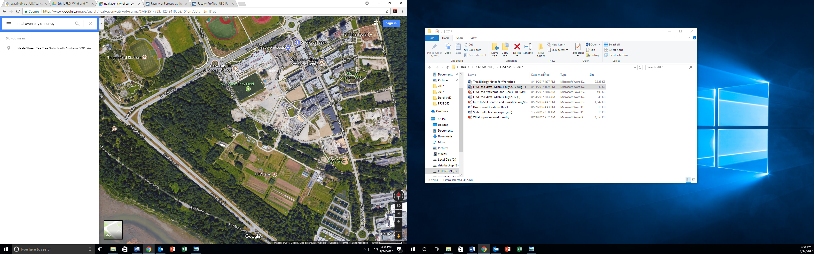

3461 Ross Drive Entrance to Farm, Meet here